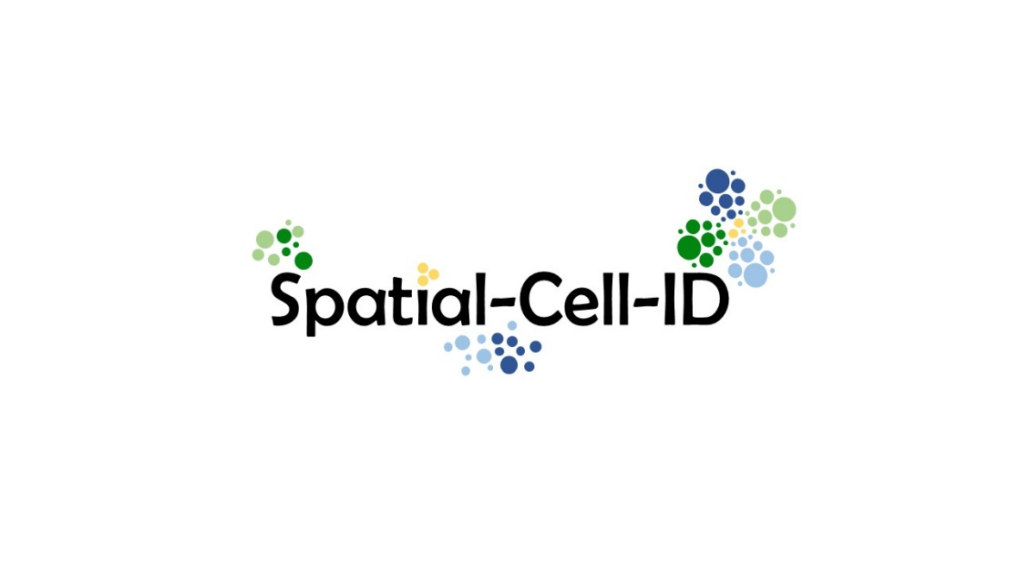

The Equipex+ Spatial-Cell-ID day will be held on April 02, 2025  
**Charles Mérieux amphitheater at ENS Lyon**(Place de l'École, 69007 Lyon).

Registration to the meeting is free but mandatory with the following link.   
(registration deadline: 21/03/2025)  
https://framaforms.org/2025-spatial-cell-id-day-1717073836

**Program**

* **09:00** - Welcome
* **09:30** - Opening and presentation of the Equipex+ by the scientific coordinators
* **09:45** - First Keynote speaker: **Davide Normanno** (IGH, Montpellier): Multiplexed single-molecule imaging at sub-cellular resolution
* **10:45** - Coffee break
* **11:15** - Presentation from Spatial single-cell RNA-Seq working group
* **11:35** - Baptiste Alberti (IGFL): Spatial-scERA: A method for reconstructing spatial single-cell enhancer activity in multicellular organisms
* **11:55** -Presentation from Slide-Seq working group
* **12:15** - Caroline Brun (INMG): Spatial transcriptomic deconvolution identifies cell-type-specific domains that associate with muscle degeneration severity in two mouse models of Duchenne muscular dystrophy.
* **12:35** - Lunch break
* **14:00** -Presentation from MERFISH working group
* **14:20** - Hugo Blanc (IGFL): MERFISH analysis pipeline: from image to spatial transcriptomic data
* **14:40** - Presentation from Data Analysis working group
* **15:00** - Marco Uderzo (IGFL): Cracking the spatial code of adult brain stem cell behaviour
* **15:20** - Coffee break
* **15:50** - Second Keynote speaker: **Anna Pascual** (CNAG, Barcelona): Spatial Omics: an overview and applications to map health and disease.
* **16:50** -Concluding remarks

**Multiplexed single-molecule imaging at sub-cellular resolution  
Davide Normanno** (**Institute of Human Genetics, Montpellier)**

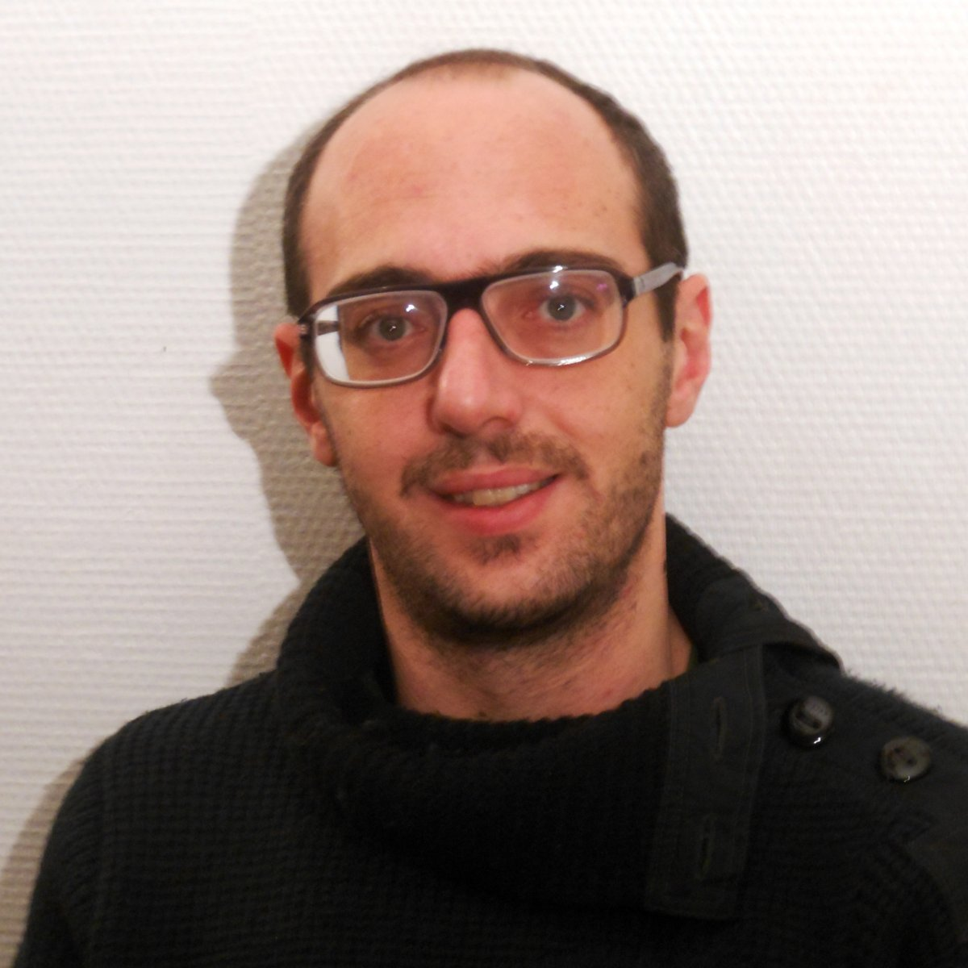

Spatial omics technologies have transformed our ability to study biological systems by integrating molecular profiling with spatial context while preserving tissue architecture. These techniques enable precise mapping of gene expression, protein localization, and DNA organization within complex microenvironments.

In this seminar, I will introduce the fundamentals of high-throughput and sequential imaging, followed by a demonstration of how multiplexed single-molecule imaging allows for the subcellular localization of individual transcripts from tens of different genes across hundreds of cells. I will then present ongoing applications of sequential imaging across diverse experimental models, including human cell lines and iPSC-derived neurons, mouse brain organoids and liver tissue sections, and Drosophila eye-disc tissues. Through these examples, I will highlight the power of multiplexed single-molecule imaging in deciphering cellular heterogeneity and tissue organization, as well as discuss key challenges and future directions in the field.

**Spatial Omics: an overview and applications to map health and disease**

**Anna Pascual (CNAG, Barcelona)**



The spatial organization of biological structures profoundly influences their function, making histopathology a cornerstone in disease diagnosis. Recent advancements the intersection of genomics and imaging have given rise to Spatial Omics, a suite of techniques capable of profiling molecules within intact tissue architectures. While each method offers varying resolution, throughput, sensitivity, and biological breadth, all possess the potential to illuminate the influence of spatial localization on cell phenotypes and disease heterogeneity and outcome, thereby revolutionizing biomedical research. Taking a comprehensive approach to Spatial Omics data analysis and integrating these with classical histopathology readouts, we employ pathology-guided and tailored methodologies to unravel the transcriptional orchestration of tissue, microenvironment, cellular and molecular functions in spatial context. This presentation offers insights into leveraging Spatial Omics assays as powerful tools to decode tissue pathology. Through examination of healthy tissues and complex disease states, such as colorectal cancer, it provides a roadmap for the characterization of compositional and organizational heterogeneity of tissues, as well as the emergence and progression of disease

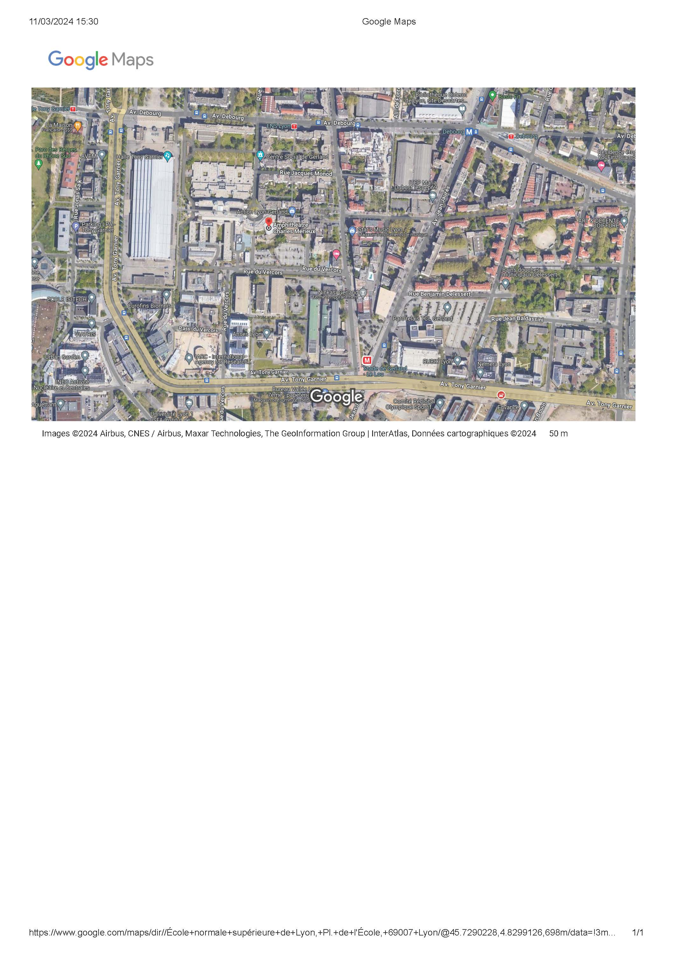

Easily accessible through the Lyon public transportation system (TCL), you can reach Amphithéâtre Charles Mérieux

**=>** by subway : line B - **stop at Stade de Gerland** or Debourg + 5 or 10 minutes walking distance

**=>** by tramway : line T1- **stop at ENS de Lyon** + 5 minutes walking distance